For part A:

RMSD=0.0167

The image is extremely blurred even though the noise is removed.

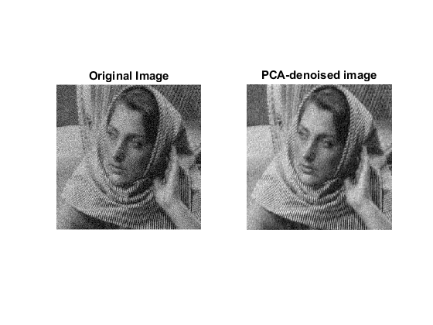

For part B,

KNN has been used

For K=25,

RMSD=0.0823

The result is as follows:

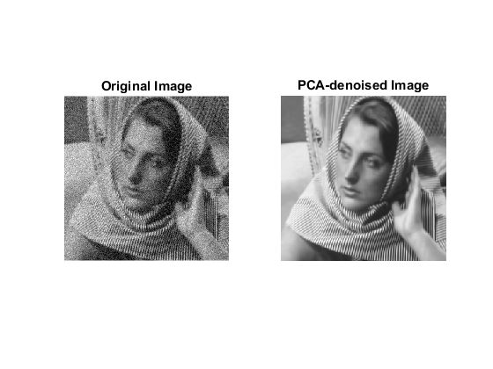

This time the denoising is far better than the previous case.

The image deviates more than the original image due to better noise removal, hence the higher RMSD.

For K=200,

RMSD=0.0573

The result is as follows:

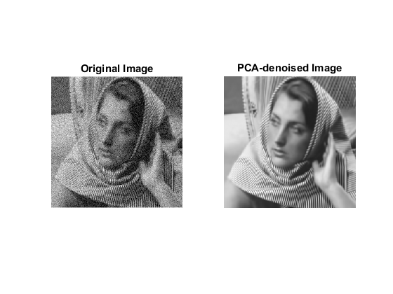

The denoising is better with K=200 than with K=25

Part 3:  
Bilateral filtered:  
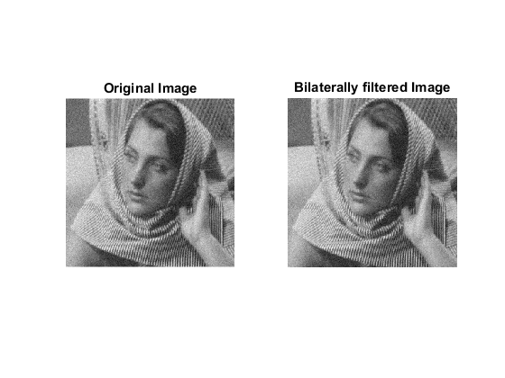

Comments:

The bilateral filter preserves significant edges well.

But it is a weighted piecewise mean filter and it does local averaging, which means that it assumes that the image is piecewise constant. So, it does not preserve underlying textures.

For PCA, there is no such assumption. The only assumption is that there are patches similar to a given patch in other parts of the image. Such similar features are captured in the eigenspace of the images. Hence PCA does better than bilateral filtering.